

**Help spread kindness!**

Please show your support for our staff and residents. Small acts of kindness can bring so much joy.

Could you…

**[your example request here]**

**[your example request here]**

**[your example request here]**

**[your example request here]**

**Or pick an act of kindness of your choice!**

All are appreciated. Feeling the support of the community means so much to us.

Please get in touch on:

**Thank you for your support**

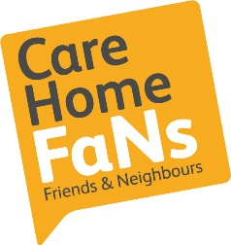

carehomefans.org