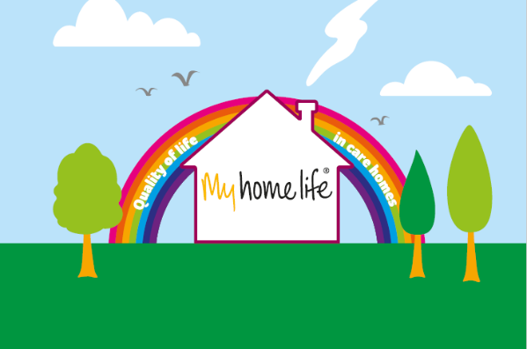

MY HOME LIFE ENGLAND: OUR UNIQUE CONTRIBUTION FOR 2021 AND BEYOND
Over 2,000 people have completed My Home Life Enterprise programmes over the last 15 years.
However, for people who live, work and connect with care homes, the COVID-19 pandemic has brought huge change.
Our programmes are shaped by listening to the sector, people who commission and support care homes and the changes that are happen in the health and social care system.
Our mission remains to develop a world where care homes are:
- Supported to deliver to their potential (Professional Development with a focus on leadership)
- Valued and trusted by those who work with them (Integration and New Ways of Working)
- Cherished by their local communities (Care Home Friends and Neighbours FaNs)

All our programmes are tailored to local priorities and we build each one following conversations with local commissioners.
The summary below provides examples of the kind of work we do but please contact us for a discussion.

My Home Life: Support, Development and Investment for and with Care Homes.
‘My Home Life’ is an international initiative, with a 15-year evidence-based history of improving quality of life in care homes and supporting culture change.
- Programme 1: Professional Support and Development including ‘Care Home Conversations’. For busy leaders who need time to reflect and plan for success. This established leadership support and development programme is built around long-term resilience, capacity and skills development in a care home. (Page 4)
- Programme 2: Creating a strong integrated joint plan in your local area as an important additional strand to programme 1. Learning about what happened through lockdown in response to COVID-19, building on and developing new working relationships, focusing on change together. (Page 5)
- Programme 3: Building closer connections with the local community (Care Home Friends and Neighbours): Support for care homes to connect with local communities to improve quality of life, open doors and create connections to people, places and passions. Helping care homes and communities regain confidence together. (Page 6)
- Programme 4: Focused Support for Individual Homes where there is concern about maintaining or regaining great quality: A small team working intensively with up to 4 homes in 1 locality. Tailoring packages of support for individual homes, using our guiding principles and supporting changes for the future. (Page 7)
At the end of each programme we provide a detailed report informed by data collection. Please do read our frequently asked questions as it gives you more detail on the practical stuff. (See Page 8 FAQ)
We have a wealth of evidence on the positive impact of My Home Life England:
- Transformational change (click here)
- Quality improvement for clinical outcomes (click here)
- Cost benefits for NHS (click here)

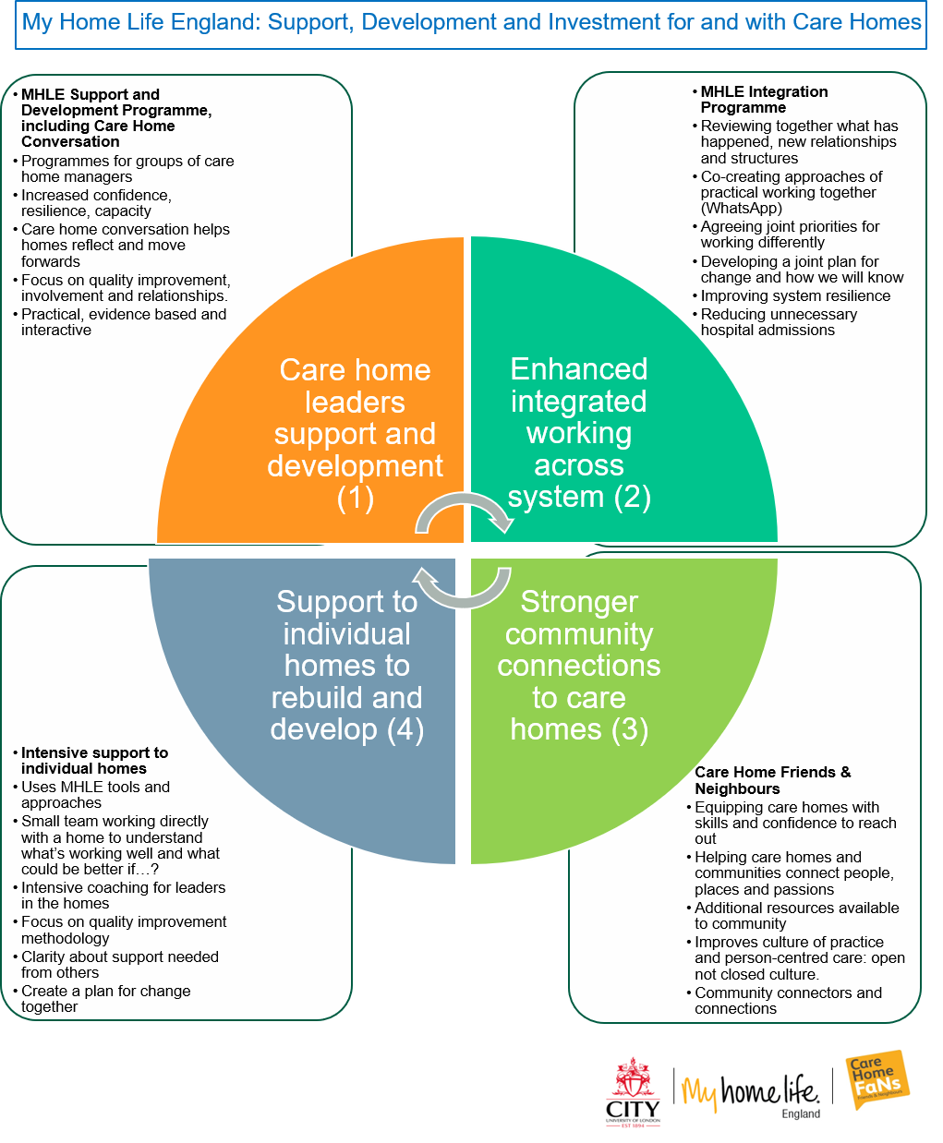

Programme 1: Professional Support and Development
This course provides support and development for care home leaders (managers/ team leaders etc) following a structured format over 9 months. It is interactive, co-produced and practical.
Through our approach we aim to provide
- Improved confidence and resilience, both personally and professionally.
- Improved engagement and involvement for people who live and work in the home and those connected with it.
- Improved leadership and responsiveness to rapid change
- Improved practice including consideration of equality, diversity, inclusion and human rights.
- Reflection and connection back to regulation requirements, local systems and relationships.
“I attend many meetings with colleagues from CQC, the CCG, our Community Health partner, heads of service at the Council and all have picked up through their own work the difference that My Home Life has made to those care homes that have participated’ Adult Social Care Manager
Data analysis of transformational change from sample tells us ‘92% report the quality of leadership they are able to provide has increased’
A new part of this course can be the Care Home Conversation work with a focus on wellbeing and resilience.
We will work alongside participants to lead a new Care Home Conversation with a focus on reflecting and looking forwards using tools we provide and the support of the action learning set and our facilitators.
This will provide:
- The opportunity for people living and working in the home to process what has happened; to rebuild resilience, confidence and capacity.
- The chance for homes to share their stories in a structured way to inform and shape local plans and approaches. The process of telling these stories will be an important part of moving forward and led by someone who has an appreciative inquiry approach and is independent.
We use 4 consistent appreciative questions in this work and record the outcomes in a consistent way.
These conversations may identify people in the home who would benefit with being signposted to one of our partner organisations who can provide pro bono counselling or support. This part of the programme will bring stories together to form part of an important narrative for the future.
We will help lead these conversations as part of the work we are commissioned to deliver and the outcomes can help inform local planning.
Additional ‘Branches’
As part of our expert group of facilitators and consultant who deliver the majority of our programme content, we can provide specific additional days which focus on:
- technology as your friend: helping people think about the changes that have happened and will happen in the use of technology and how this can support quality developments for individuals, the home and the wider system
- quality improvement approaches: using the quality improvement/patient safety approaches and priorities in an appreciative way building on current national priorities
- working well with people with a diagnosis of dementia: up to 80% of people living in care homes may have dementia. Developing the MHLE frameworks with a particular focus on great support for people with dementia and their families/supporters.

Programme 2: Creating a strong integrated joint plan in your local area as an important additional strand
Local public sector leaders in areas we work have recognised the impact of our programmes.
We have an established a wider programme including local system leaders where plans have developed together on challenging areas including:
- admissions to hospital from care homes.
- quality improvement as a positive tool.
- winter pressure plans.
- acute and community service redesign.
We can provide this additional strand to the programme that connects local leaders together with people on the programme with a particular focus on learning from changes in response to COVID-19. Some questions we might want to consider include:
- What has worked well and is working well?
- How do we support care homes to retain and be confident in creating relationships and environments that reflect the fact that people live there?
- How local systems can plan together for the future and how does the language we use and the way we understand quality impact on how we work together?
- How will new policy and practice changes affect care homes and their role in local community services, including discharge from hospital to care homes and enhanced health in care homes?
- What does integration mean for people who live, die work in and visit are homes and what would good like as outcome of change?
Our team will build the local programme using the My Home Life England approach, linking the programme back to local priorities. Care home leaders can help shape solutions at a very local level and at a wider system level.
Through our approach we will provide:
- A clear diagnostic of current system planning and how care homes are working with local commissioners and people who have a new responsibility to support care homes.
- Co-creation of a small number of shared priorities to take forward (e.g. hospital discharge, improved access to support) based on local priorities and new national policy.
- Facilitated workshops with local leaders, including care home managers, to agree next steps to increase resilience within care homes, across primary care networks, at local ‘place’ within a local authority and across a wider accountable network, for example acute service review team or integrated care system.
- Links to other places we are working and the resources we have.
- Potential new ways of using data already collected to support a more integrated approach.
- The offer of follow up sessions to support implementation.
An example of the impact we can have by this approach is shown below for urban area:
- Ambulance callouts – 14% decrease and Ambulance conveyances – 16% decrease
- A&E attendances – 9% decrease and Non-Elective admissions – 5% decrease
(Annual trends for 2018-2109 compared to the previous 2 years)

Programme 3: Building closer connections with the local community (Care Home Friends and Neighbours FaNs)
We have a well-established, research-based initiative which supports care homes to connect meaningfully with the local community called Care Home Friends and Neighbours.
Managers are telling us about the inspiring support they have received from local communities during the pandemic. They also remind us about the challenge of staying connected to people who do not live or work in the homes, including family, supporters and friends.
This programme recognises that community involvement and engagement needs to be supported and developed as part of how ‘we do things around here’.
This can be time consuming and is not as easy as it sounds. The content of this course has been specifically adapted in response to COVID-19 and the need to help care homes and local communities rebuild confidence in connecting with each other, building on the great examples we have heard about and promoted.
Through our approach we aim to provide:
- Support for homes to widen networks and open up opportunities using our tools and resources, including links to our own dedicated network.
- Consideration of the difference between a ‘closed’ and ‘open’ home and culture.
- An opportunity for the local community to understand what living and working in a care home is like and the contribution they bring.
- Support to create connections now, sustainable as communities adapt to the impact of the pandemic.
- Participation in ongoing research which continues to develop evidence that community connections improves the quality of life for all involved.
We will work with you to develop care home community champions in a local area. These posts could be part of the care home support and quality team, linking to volunteers with a defined role who can start to map community assets, home assets and use new IT and virtual systems to start this process. There are strong links in this programme to social prescribing and community navigation.
Programme 4: Focused Support for Individual Homes.
Drawing on the experience of My Home Life Scotland, and in response to requests we have had, we can provide focused support for individual homes using our guiding principles and an appreciative inquiry approach.
This programme will be delivered through a small team drawn from the MHLE core team, our facilitators and partners.
Through our approach we will provide:
- The opportunity to work intensively with up to 3 or 4 homes at a time in locality.
- Using our guiding principles of relationship centred care, caring conversations, appreciative inquiry and best practice to understand what is working well and ‘what could be better if…’
- Structured evaluation
- Detailed and supportive feedback while we are working in the home, promoting best practice, helping everyone in the home to understand why change might be hard.
- Provide intensive training for care home managers to feel confident in leading change.
- Work with the home and local stakeholders to agree a positive plan and support that will be needed from outside the home to achieve goals.
- A focus on quality improvement methodology.
There will be clarity about our role and those of others who have a formal requirement to quality assure care homes.

All programmes provide
- Enhanced support for care homes.
- Research led approaches to embed dignity, compassion and relationship centred care.
- Developments in collaborative working and learning together for the future.
- Flexibility in relation to local priorities, but linking to policy requirements and regulation.
For more information contact:
Steph Thompson Tom Owen
Email Steph.Thompson@city.ac.uk. Email Tom.Owen.1@city.ac.uk
Tel: 07786107951 Tel: 07910198634

Some Frequently Asked Questions
- How many people can join a programme?
We are happy to work flexibly with you, depending on the option you choose. We can facilitate learning in different ways and all our programmes will respect up to date advice on social distancing, utilising new virtual technology and face to face meetings. However, we know from 15 years experience that our programmes work most effectively for groups of up to 18 people, with action learning in smaller groups of up to 6 people in virtual learning sets.
- How to you assure the quality of what you do?
We employ expert facilitators and we have an assessment and induction prior to someone joining the MHLE team. We hold individual and team review meetings on a regular basis. A senior member of our team liaises with the funder and provides a final report, which is validated by participants for resonance, relevance, and permission to share with a wider audience. We actively encourage funders to examine routinely available data to explore its wider impact. We are happy to provide references from past commissioners and participants.
We are a learning organisation and gather evaluative feedback from participants on the process and outcomes of the programme. New ways of working and resources aligned with the MHLE vision are co-created with national experts working in partnership with care homes.
- How much does it cost?
This does depend on which option you choose. We benefit from being part of City, University of London, the International ‘My Home Life’ Community and the calibre of the facilitators we employ. We are transparent about our costs and will break these down if necessary.

- How does what you do help homes with CQC inspections and quality assurance systems?
We encourage participants to keep evidence of the impact of any change in practice to inform their CQC inspection. MHLE was endorsed in the White Paper for Social Care Reform, prior to the Care Act 2014. It was also promoted by the CQC, alongside NICE social care quality standards and the Dementia Care and Support Compact. It has informed and been endorsed by several Commissions/Policy reports across the UK. We support participants to reflect all the time on how the learning they experience from our programmes links back into systems being used to assess quality. Every course has a focus on quality.
- What happens on the programme and what do participants gain at the end?
The introductory workshop days to our programmes are well established. Our programme currently has an emphasis on COVID-19, learning together about what has worked well and what we can build on together for the future. Each programme is bespoke but we will set it out in detail for commissioners and then participants.
MHLE is typically seen to be transformative by participants and the final reports that we provide will evidence this. On completion of any course, participants are invited to become My Home Life ‘associates’ and stay connected with both local and national networks for on-going support. Participants’ learning can be used as evidence as part of academic qualifications. Programme participants can also be connected to unique opportunities for further learning/career development, including presenting at conferences, advising research and mentoring others.
- How long does a course take?
This depends on which option is undertaken. We are flexible in our offer and open to delivering bespoke programmes. However, Option 1 would take around 9 months including COVID-19 care home conversations. Option 2 would take more days in the same timeframe. Care Home FaNs can be a stand-alone initiative and would take approximately 6 months.
- What difference will a course make?
We have a wealth of evidence on the positive impact of MHL
- Transformational change (click here)
- Quality improvement for clinical outcomes (click here)
- Cost benefits for NHS (click here)

We can work with local teams to agree ways in which we measure how a MHLE programme can support local quality, innovation, productivity and prevention schemes, quality development schemes, retention and recruitment, collaborative working and other options, but we need to agree this with you on an individual basis. We would need system partners help for some indicators to be measured and always be mindful of GDPR. We produce detailed reports at the end of each programme including recommendations for the future, based on our approach and participants experience and learning.
- How can you ‘scale up’ for more homes across our area?
We know the evidence-based leadership programme will not work for large numbers at once. However, as we all adapt to new ways of working and there is more demand for the work we do, we are developing new options without diluting our quality. These can include:
- Deliver our WhatsApp approach across a large number of care homes led using a core of managers who are also participating on our programme.
- Develop FaNs as a standalone course.
- Have 2 or 3 leadership programmes running on one area, with action learning being delivered using new technology.
- Work to recruit more facilitators across an agreed geography (for example an integrated care network).
- Working with you to train and supervise and support people to join your team in the local area once we have delivered a programme where they would work.

-

